

Advanced Databases

Section A

Group Y

Food Inventory Data Mart

Eoin Fitzsimons- x23151374

Conor Judge- x22165398

Food Inventory

Eoin Fitzsimons (Profit) – Conor Judge (Perish)

Introduction 2

Business Requirements. 3

Food Waste **Error! Bookmark not defined.**

Profits 3

Dimensional Model. 4

SQL – Fact & Dimension Tables. 5

SQL – Data into Mart. 6

Queries 10

Food Waste. 10

Profit Per Ingredient. 11

Changes made to optimise read access. 14

References 15

# Introduction

When faced with the task of designing a data mart for a business within food inventory we were unsure which of the many options was best to pick; we ended up settling on a restaurant with the onus of the mart being the stockroom of individual ingredients. Two thoughts immediately emerged when deciding upon the business requirements; perishability and profit. We did not find a ready-made database that suited our needs enough, so endeavoured to make our own. We started with what information we would like to obtain from our queries and then worked backwards to flesh out the table and make it appear more realistic akin to how a genuine restaurant would keep track of its produce.

We devised an artisanal culinary experience that stays true to the roots of our vegetables and wants to be carbon-positive. All our food is prepared without electricity, and we only refrigerate and freeze a minuscule amount of ingredients to have the lowest emissions. We have a direct link to the local vegetable farmers and even have our plots within the restaurant to provide that mesmerising organic dining moment™.

We assume this is popular and not a complete waste of time.

# Business Requirements.

## Perishability

A key issue for any business that deals with food will be managing waste. Spoiled items cannot be used or sold and have another further cost in the form of waste disposal. Restaurants must invest in facilities to store the food in appropriate environments to prevent waste.

Being able to identify items that are most and least likely to spoil can be used to change buying and storage patterns.

Storage areas where a significant amount of waste occurs can be identified to adjust storage conditions, implementing better inventory management practices, or reevaluating the allocation of ingredients to different storage areas.

## Profits

All businesses need to make money to run. A restaurant is no exception, our restaurant needs to purchase ingredients and then the meals will make use of ingredients and sell to customers.

The inventory manager for a restaurant may want to observe multiple dimensions to examine why ingredients are profitable. They should see whether they ought to raise prices or cut costs and obtain the ingredients differently.

To do this they could examine the ingredient dimension to see what produce is bought and sold. Then take note of how much is spent in procurement, and how much an ingredient brings in when used in one of the restaurant's wonderous dishes.

They could also see which country the produce has arrived from to inspect whether the distance the product travels has proportionality with the profit margin. Is the premium on local artisanal goods worth it when compared to mass-produced goods from elsewhere?

Then the inventory manager would examine the characteristics of the ingredients to see which taste has the most profound impact on the profit margin. Is it those sweet ingredients that you only need a minuscule amount of to tie a dessert together? Or should the restaurant focus on those foundational vegetables of society that grow in abundance and are bought at dirt-cheap prices?

# Dimensional Model.

# SQL – Fact & Dimension Tables.

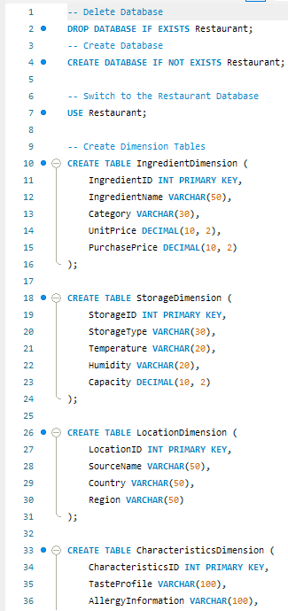

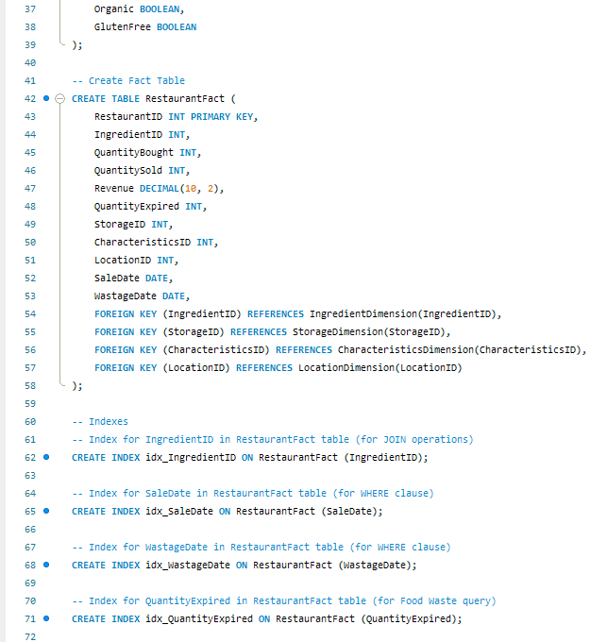

# SQL – Data into Mart.

# Queries

## Food Waste.

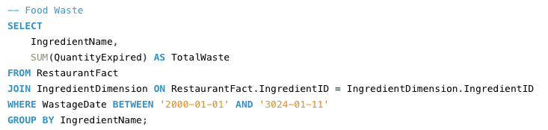

## Profit Per Ingredient.

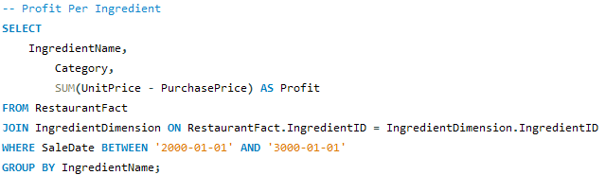

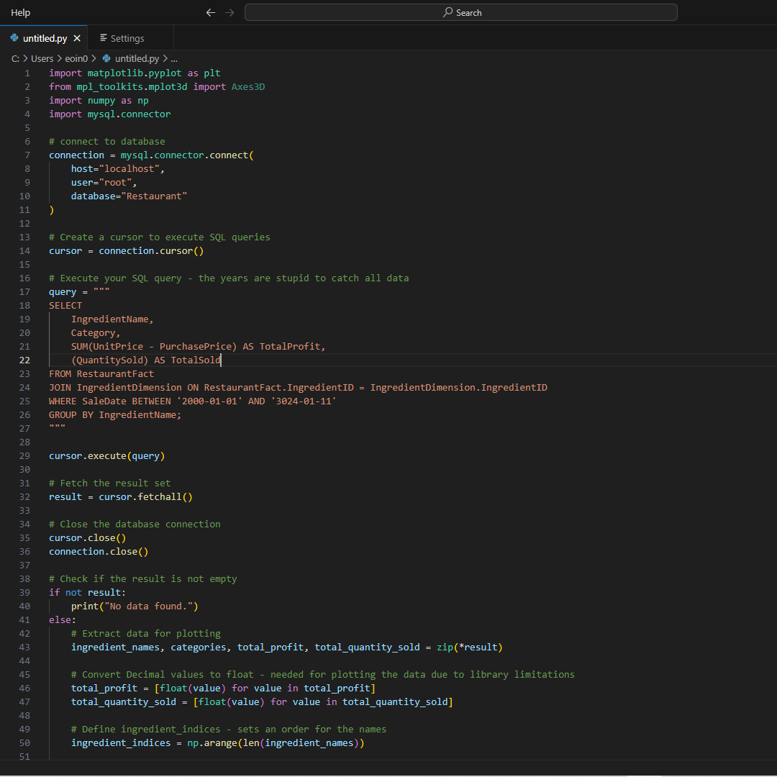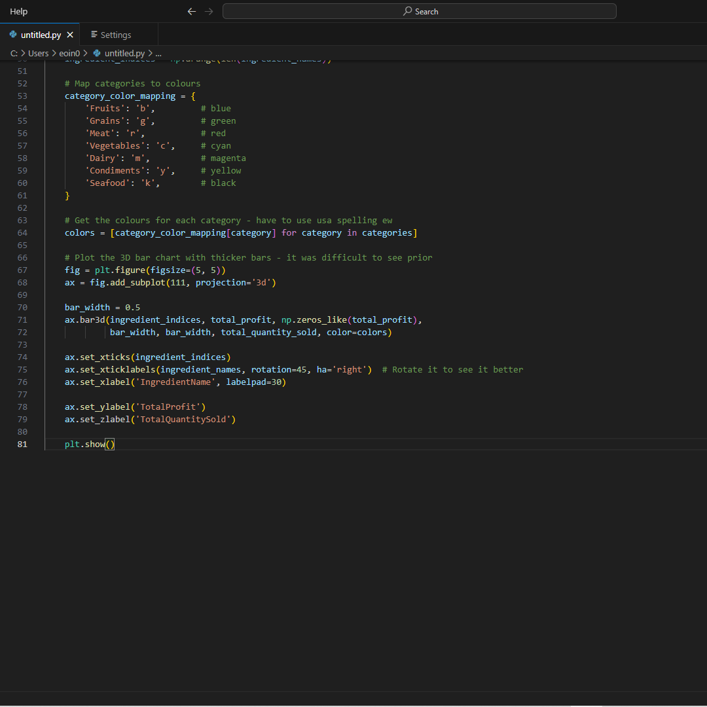

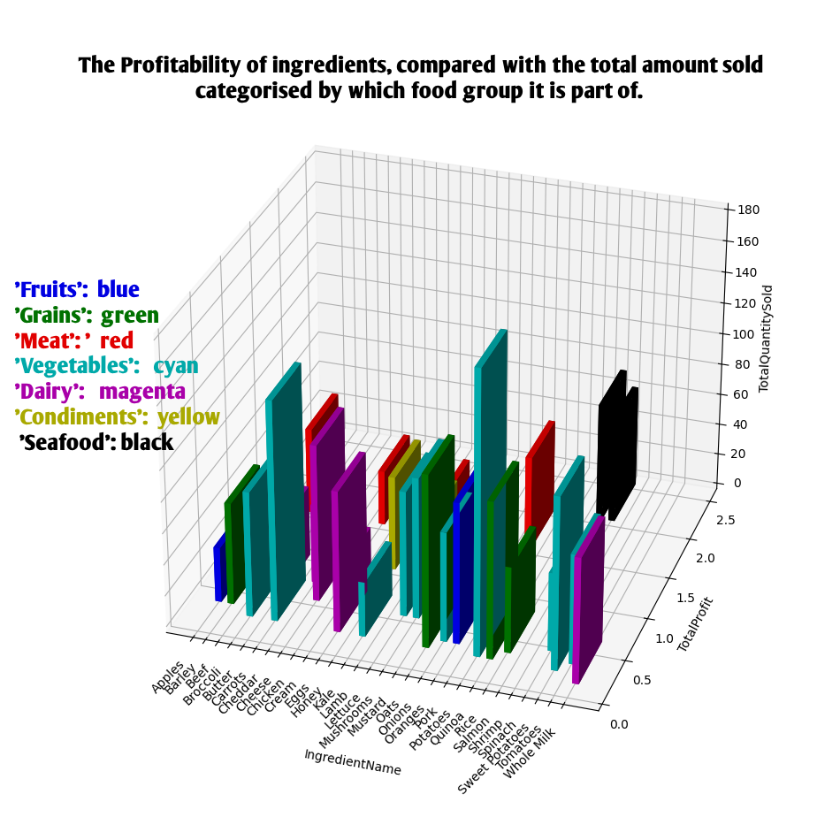

Potatoes have the highest quantity sold but a rather meagre profit, this tells us that the price we sell it at can be increased.

Kale has the lowest profit and the second lowest amount sold; we need to reduce the price we buy it.

All types of seafood have a good profit margin and a middling amount of sales; this would imply we are selling it correctly.

# Changes made to optimise read access.

A star schema was chosen for our relationships rather than a snowflake as all our customers are stars of the world. The star schema allows us to achieve faster querying speeds due to its relative lack of complexity in comparison to the snowflake. This will allow us to gain insight into the ever-changing situation of stockroom inventory. The perishable nature of many of our products is what encourages us to use a system of less normalisation with a focus on greater write and read speed, which will allow those who need to read queries to get the answers they seek faster. This allows us to better reach our business requirements of minimising waste and maximising wealth.

We indexed our table through the field of ingredient name, this was done by

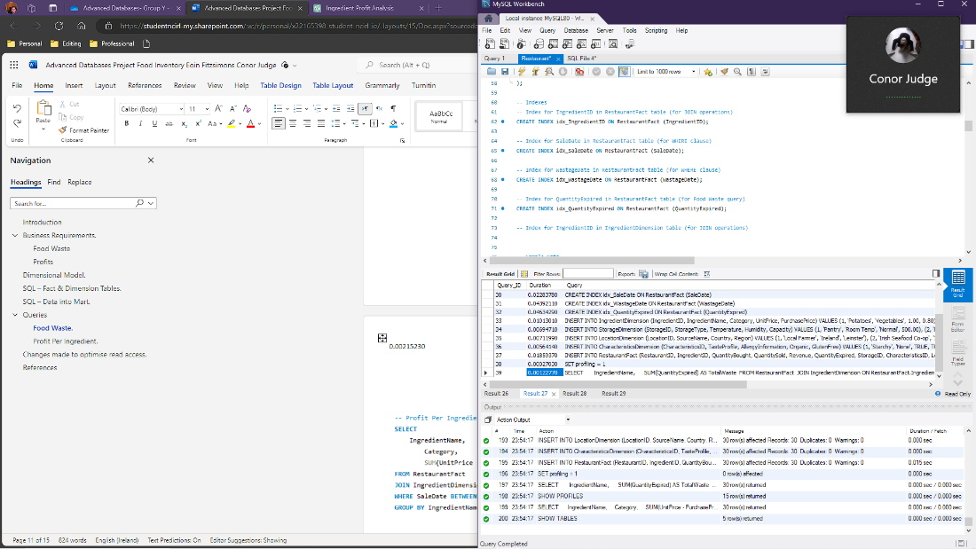

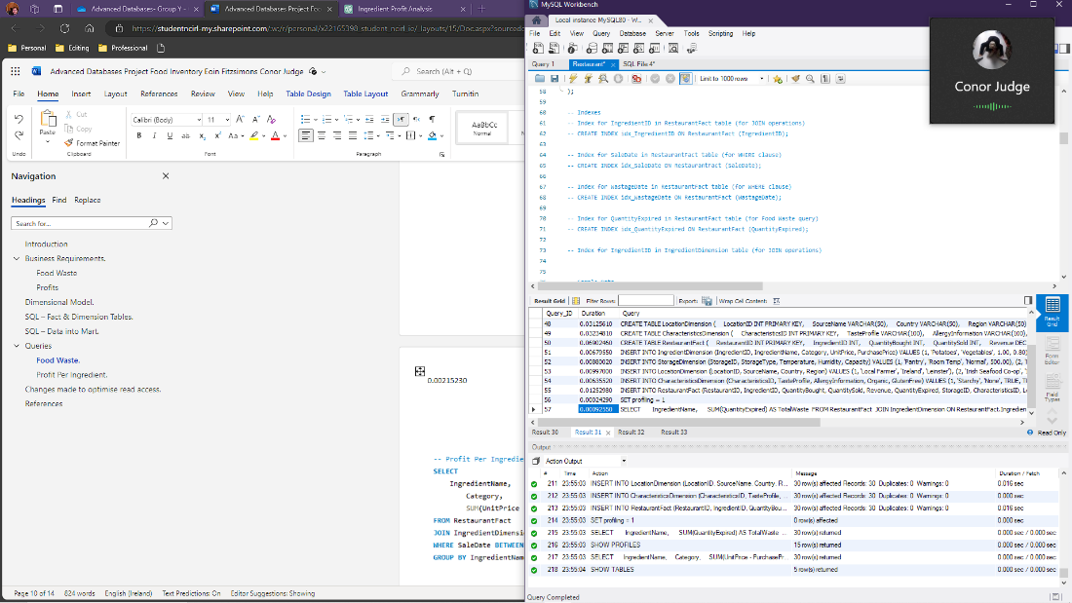

# References

We used ChatGPT to generate the data, we found it was the most reliable for pairing foodstuff to its real characteristics. It was also used for assistance in formatting the graph of profit.